**Mountainside Condominiums**

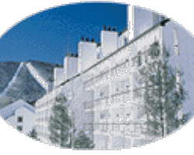

**190-251 Mountainside Drive, Warren, VT 05674, USA**

Mountainside’s deluxe one and two bedroom units are located in the heart of the Sugarbush Village at Sugarbush South (aka Lincoln Peak). No need to get back in your car – located on the trail to the mountain’s lifts and a stone’s throw to a variety of restaurants, Pubs, Pizza and Child Day Care. Guests love the unique convenience of being able to ski directly to Mountainside Ski Shop, drop off equipment for tuning, pop in to Rex’s for a Heady Topper, then pick up a Pizza and the kids before heading home!

Mountainside is the only private association on the mountain with a heated pool (heated June 15 – Mid Sept). Enjoy the trail walks along our babbling Rice Brook, mountain biking, and disc golf. Or chill out with a book on your unit’s private patio. The choice is yours and Mountainside offers easy access to all the options!

Units feature a ski locker, fully-equipped kitchen, cable TV, WiFi (washer dryers and gas fireplace depending on the unit).

All one bedroom units sleep two per bedroom and two in the living room accommodations.

The two-story loft units feature a bedroom and bath on the main level and a sleeping loft and bath on the upper level with sleeping from 2-4 depending on the unit, washer/dryers, fully equipped kitchens and some with gas fireplaces.

The Mountainside Ski Shop, Bus Stop, and Day Care Center are right here in Sugarbush Village, with Sugarbush Sports Center and all the great activities at the Resort within a short walking distance. The Sports Center features an indoor pool, hot tub, exercise facilities and classes, indoor tennis, racquetball squash courts, and massage.